Appendix 5 – Efficient Analysis of the ImageJ Histogram Data using Excel

Open up the saved histogram file from ImageJ using Excel. You will have to import it… select Yes and Next when prompted. The file that will open up will have two columns: Value (the ImageJ color code) and Count (the number of pixels of that color value). First, sort the data via the column Count, from largest to smallest (there are a total of 255 values). You can ignore the many rows that have values with zero counts. Then, for the values that have non-zero count data, calculate the sum of all counts, the sum of the counts of the four land cover classes that correspond to forest (values 61, 127, 179, 215; see Table 1). Next, calculate the proportional coverage of forest (= forest counts / total counts).
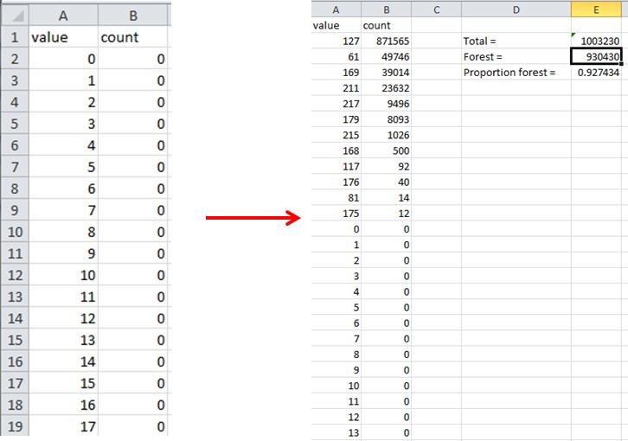
Fig. 1 ImageJ histogram data before and after data processing in Excel.
Table 1. Key for translating ImageJ Color codes to the 2001 and 2006 NLCD land use / land cover classes.

